**Churn dataset queries**

use churn_DB;

select * from customer_churn;

/* data cleaning */

update customer_churn

set multiplelines = 'No'

where multiplelines = 'No phone service';

update customer_churn

set OnlineSecurity = 'No'

where OnlineSecurity = 'No internet service';

update customer_churn

set OnlineBackup = 'No'

where OnlineBackup = 'No internet service';

update customer_churn

set DeviceProtection = 'No'

where DeviceProtection = 'No internet service';

update customer_churn

set Support_used = 'No'

where Support_used = 'No internet service';

update customer_churn

set StreamingTV = 'No'

where StreamingTV = 'No internet service';

update customer_churn

set StreamingMovies = 'No'

where StreamingMovies = 'No internet service';

alter table customer_churn

add usage_segment varchar(20);

alter table customer_churn

drop column usage_segment;

update customer_churn

set usage_segment =

case

when app_usage_month between 1 and 8 then '1-8 months'

when app_usage_month between 8 and 18 then '8-18 months'

when app_usage_month >=18 then '18+ months'

else 'unknown'

end;

select distinct(plan_type) from customer_churn;

/*churn rate by plan_type*/

with cte as(

select plan_type, count(*) as total_ppl,

sum(case when churn = 'Yes' then 1

else 0

end) as ppl_churned

from customer_churn

group by plan_type

)

select plan_type,ppl_churned, total_ppl, round((ppl_churned *100)/ total_ppl,2) as churn_rate_pct

from cte;

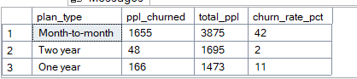

/*churn rate by account_tier*/

with cte as(

select account_tier, count(*) as total_ppl,

sum(case

when churn = 'Yes' then 1

else 0 end)as churned_ppl

from customer_churn

group by account_tier

)

select account_tier, churned_ppl, total_ppl, round((churned_ppl*100)/total_ppl,2) as churned_rate

from cte;

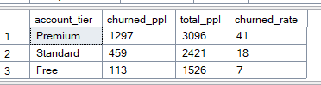

/*churn rate by gender*/

with cte as(

select gender, count(*) as total_ppl,

sum(case

when churn = 'Yes' then 1

else 0 end)as churned_ppl

from customer_churn

group by gender

)

select gender, churned_ppl, total_ppl, round((churned_ppl*100)/total_ppl,2) as churned_rate

from cte;

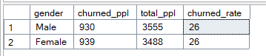

/*churn rate by usage_segment*/

with cte as(

select usage_segment, count(*) as total_ppl,

sum(case

when churn = 'Yes' then 1

else 0 end)as churned_ppl

from customer_churn

group by usage_segment

)

select usage_segment, churned_ppl, total_ppl, round((churned_ppl*100)/total_ppl,2) as churned_rate

from cte;

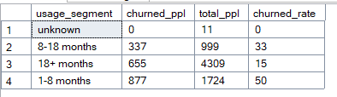

KPI’s

select sum(monthlySpend) from customer_churn;

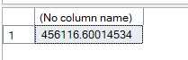

select count(customerid) from customer_churn;



select avg(app_usage_month) from customer_churn;



select round(sum(MonthlySpend)/count(customerid),2)

from customer_churn;



SELECT

COUNT(*) AS total_customers,

SUM(CASE WHEN churn = 'Yes' THEN 1 ELSE 0 END) AS churned_customers,

ROUND(

SUM(CASE WHEN churn = 'Yes' THEN 1 ELSE 0 END) * 100.0 / COUNT(*), 2

) AS churn_rate_percent

FROM customer_churn;

